Pretérito Song
Extra Credit
Due on January 30th J Day

Chicas, do you want extra credit?
You may record a video of students singing a song on how to conjugate in the Pretérito.
- You may pick whatever song you want as long you use the instrumental version or the clean version for the background.
- Make your own lyrics and explain the following Pretérito endings:

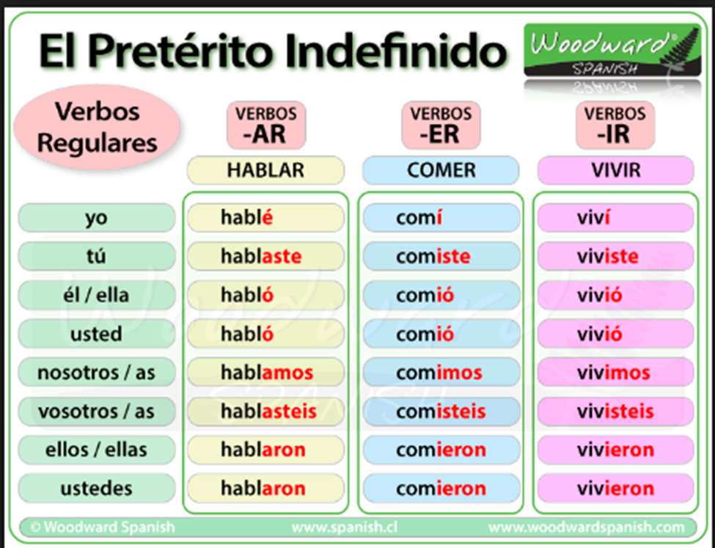
- In the video every single member of the team has to be singing and it has to look active at all times.
- You need to write a Google Doc or Word Document of the lyrics of your song. Also, add a link to the original song, as well.
- Do not forget to write all the names of your classmates.
- Present the video in class on Wednesday, January 30th, 2019 (send me the link to your video)

